KARNATAK LAW SOCIETY’S

GOGTE INSTITUTE OF TECHNOLOGY

UDYAMBAG, BELAGAVI-590008

(An Autonomous Institution under Visvesvaraya Technological University, Belagavi)

**(APPROVED BY AICTE, NEW DELHI)**

Department of Electronics AND Communication



*An Internship Report on*

**FORECASTING WIND POWER USING MACHINE LEARNING**

*Submitted in the partial fulfillment for the award of the degree of*

**Bachelor of Engineering**

**In**

***Electronics and Communication Engineering***

*Submitted by*

**NAME OF THE CANDIDATE**

**AISHWARYA CHANDRASHEKAR**

**USN**

**2GI16EC009**

Internship Carried Out

at

**VENA ENERGY INFRASTRUCTURE SERVICES PRIVATE LIMITED, BENGALURU**

**Internal Guide** **External Guide**

**2019 – 2020**

Department of Electronics and Communication

KARNATAK LAW SOCIETY’S

GOGTE INSTITUTE OF TECHNOLOGY

UDYAMBAG, BELAGAVI-590008

(An Autonomous Institution under Visvesvaraya Technological University, Belagavi)

**(APPROVED BY AICTE, NEW DELHI)**

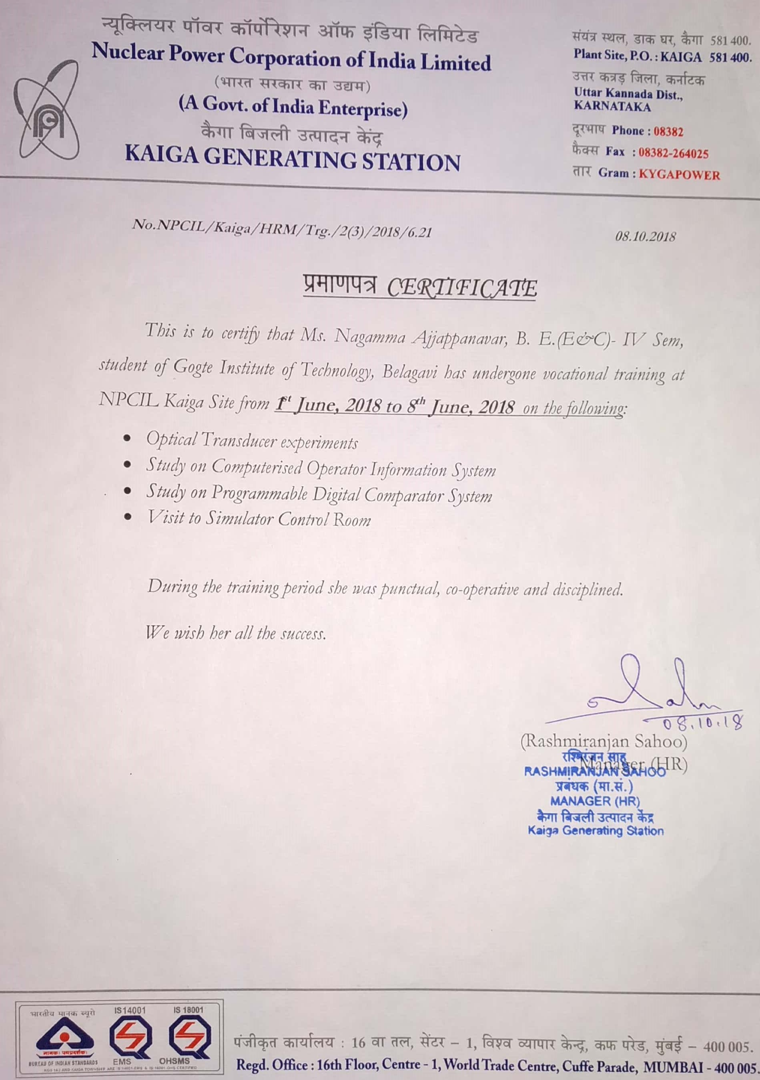

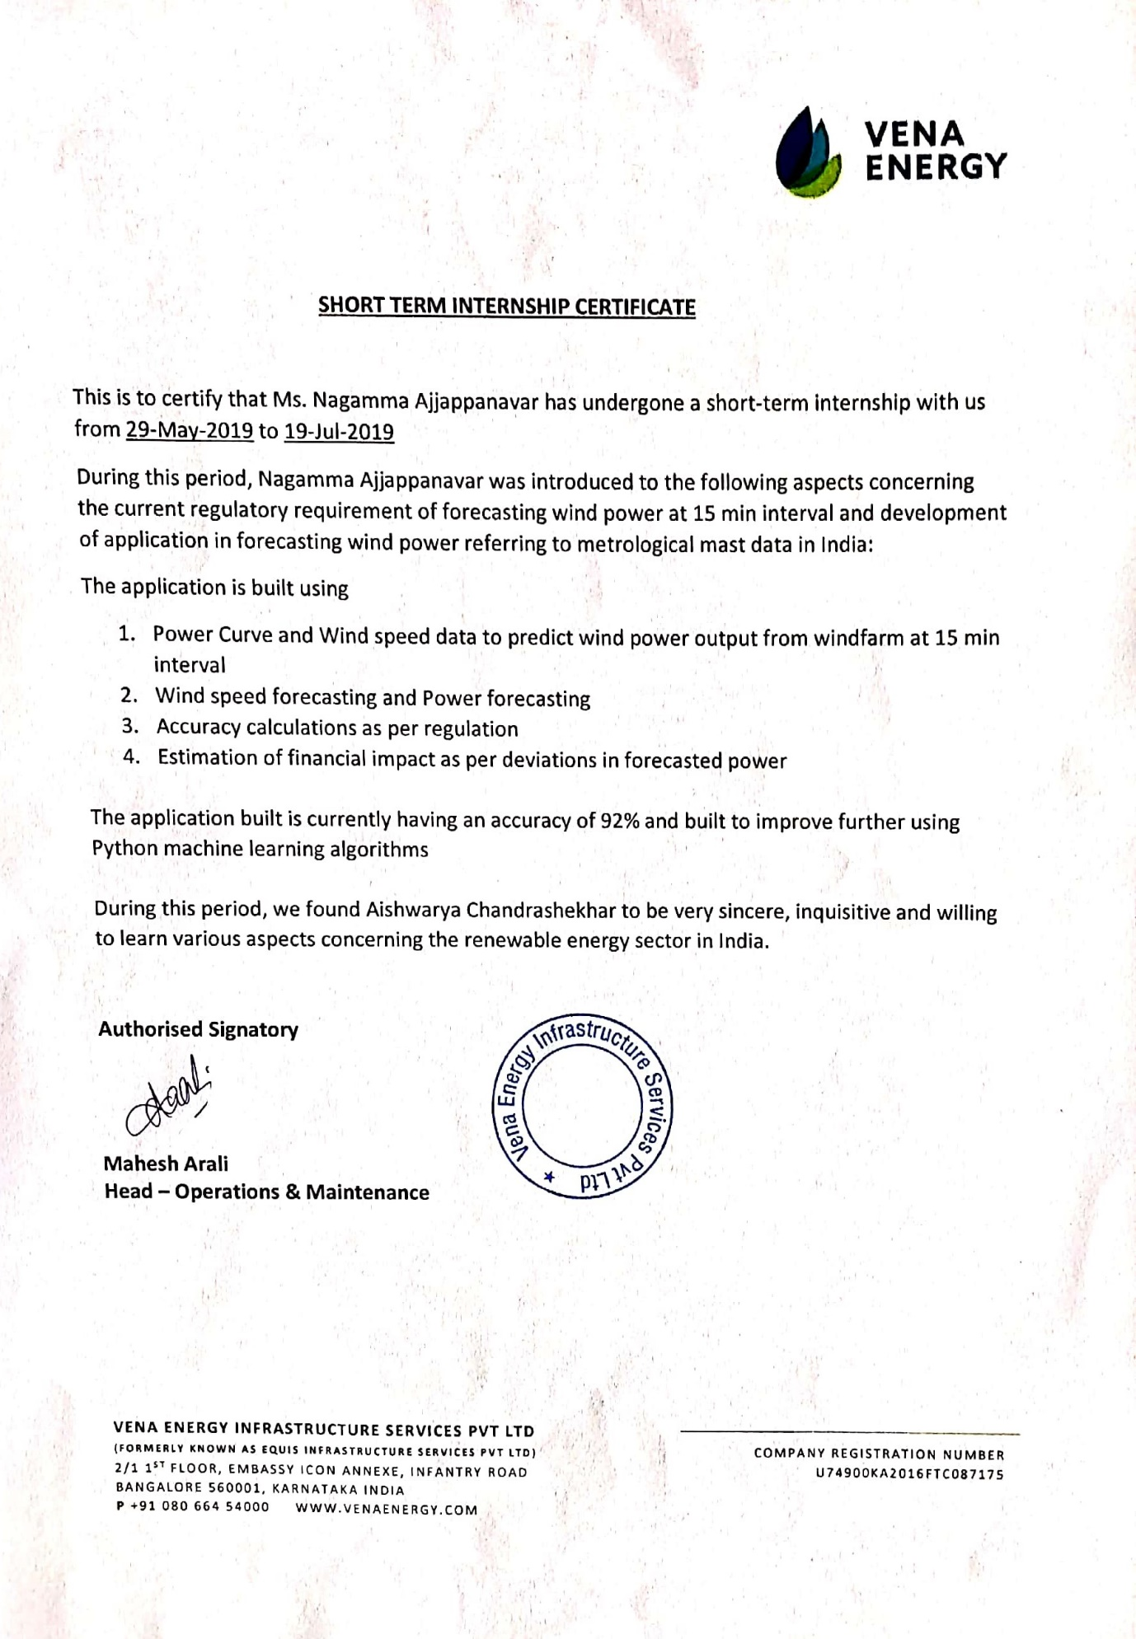

 

**CERTIFICATE**

Certified that the internship entitled Forecasting wind power using machine learning done at Vena energy infrastructure services private limited, Bengaluru Pvt Ltd. is a bonafide work carried out by Ms. Nagamma Ajjappanavar USN :2GI16EC083 in partial fulfillment for the award of **Bachelor of Engineering** in Electronics and Communication of the Visvesvaraya Technological University, Belagavi during the year 2019- 2020.

It is certified that all corrections/suggestions indicated have been incorporated in the report. The internship report has been approved as it satisfies the academic requirements in respect of Internship prescribed for the said Degree.

Signature of the Guide        Signature of the HOD        Signature of the Principal

**External Viva-Voce**

|  |  |  |  |
| --- | --- | --- | --- |
|  | **Name of the examiners** | **Date of Viva -voce** | **Signature** |
| **1.** |  |  |  |
| **2.** |  |  |  |

**DECLARATION BY THE STUDENT**

I, Nagamma Ajjappanavar hereby declare that the internship report entitled forecasting wind power using machine learning and Control System submitted by me to KLS Gogte Institute of Technology, Belagavi, in partial fulfillment of the Degree of Bachelor of Engineering in Electronics and Communication is a record of the internship carried out at VENA ENERGY INFRASTRUCTURE SERVICES PRIVATE LIMITED, PVT LTD and NPCIL. This report is for the academic purpose.

I further declare that the report has not been submitted and will not be submitted, either in part or full, to any other institution and University for the award of any diploma or degree.

Place: Belagavi Name of the student: Aishwarya Chadrashekar

Date: 08/08/2019 USN: 2GI16EC009

Signature of the student

Acknowledgement

This internship work consumed huge amount of work, research and dedication. The internship would not have been possible if I did not have received support of many individuals and organizations for their incredible knowledge. Therefore, I would like to extend my sincere gratitude to all of them. In particular, I would like to take this opportunity to express my honor, respect, deep gratitude & genuine regards to the staff of **Department of Electronics and Communication Engineering** of **KLS’s Gogte Institute of Technology, Belagavi** for providing me all the guidance required for the completion of the internship.

I sincerely would like to thank my guide **Prof. Nikhil Inamdar** for guiding me throughout this internship and also would like to thank my **Electronics and** **Communication Dr. S. S. Saraf** for giving an opportunity for the completion of internship work and giving me a platform to showcase it.

I sincerely would also like to express my deep gratitude and thankfulness to **external guide** for providing me an excellent opportunity of internship at **“VENA ENERGY INFRASTRUCTURE SERVICES PRIVATE LIMITED”** without which my work would not have been completed.

My Sincere thanks to **Dr. A.S Deshpande**, Principal, KLS’s GIT, and Belagavi who have given me opportunity of the completion of this internship.

Last but not the least I would like to thank all the people who have helped me directly and indirectly for making my internship work successful.

**(Name of the Candidate)**

AISHWARYA CHADRASHEKAR

**EXECUTIVE SUMMARY**

I have completed my internship in VENA ENERGY, which is the largest independent renewable energy company in Asia Pacific region and NUCLEAR POWER CORPORATION OF INDIA LIMITED (NPCIL), which is a government-owned corporation of India based in Mumbai in the state of Maharashtra. Throughout the internship, I had been learning different machine algorithms and how the data stored in data base management system (demo) and control systems. This report was written after getting the first-hand experience from machine learning ARIMA model. This report explains the importance of machine learning in present era and help the reader to get idea about the various usage machine learning using python, its importance and the most importantly its day to day applications.

Objectives of the internship:

To learn the machine learning algorithm and implemented them using programming language python until we get accuracy up to expected level.

To maximize the power generation and profitability from nuclear power stations with the motto ‘safety first and production next’.

To increase nuclear power generation capacity in the country, consistent with the available resources in a safe, economic and rapid manner, in keeping with the growth of energy demand in the country.

Internship has helped me to understand how to forecast power from the wind speed and how the programmer should write program to meet accuracy level and helped me to understand the behavior in the cooperative world and the interaction in the cooperative world.

The successful completion of this internship indicates that the future of the world is going towards the new arriving technologies and the major role in this transformation is played by machine learning which minimize labor problem.

**TABLE OF CONTENTS**

|  |  |  |  |
| --- | --- | --- | --- |
| **Chapter No.** |  | **Content** | **Page No.** |
|  |  | Declaration | I |
|  |  | Acknowledgement | Ii |
|  |  | Executive Summary of the Internship | Iii |
|  |  | Table of Contents | Iv |
|  |  | **PART-A** |  |
| **1.** |  | **Description of the company/institution** | **10-12** |
|  | 1.1 | Introduction of the company | 10 |
|  |  | 1.1.1.Cability | 10 |
|  |  | 1.1.2.Project Development | 10 |
|  |  | 1.1.3.Construction Management | 11 |
|  |  | 1.1.4.Operation and Maintance | 11 |
|  |  | 1.1.5.Corporate PPAS | 12 |
|  |  | 1.1.6.Contact details | 12 |
| **2.** |  | **Internship activities** | **13-24** |
|  | 2.1 | Wind power forecasting | 13 |
|  | 2.2 | Reason for wind power forecasting | 14 |
|  | 2.3 | Autoregressive Integrated Moving Average Model (ARIMA) | 15 |
|  | 2.4 | Programs and Output | 17 |
|  |  | 2.4.1.Reading csv file | 17 |
|  |  | 2.4.2.ARIMA Model | 17 |
|  |  | 2.4.3.Training and Test | 19 |
|  |  | 2.4.4. Accuracy | 21 |
|  |  | 2.4.5. Power Forecasting | 22 |
|  |  | 2.4.6.Deviation | 23 |
|  |  | 2.4.7.Penalty | 25 |
|  |  | **PART-B** |  |
| **1.** |  | **Description of the company/institution** | **26-27** |
|  | 1.1 | **About Company** | 26 |
|  |  | 1.1.1.History | 27 |
| **2.** |  | **Internship activities** | **28-39** |
|  | 2.1 | Experiments on transducers | 28 |
|  |  | 2.1.1.characteristics of photovoltaic cell | 28 |
|  |  | 2.1.2.characteristics of pin photodiode | 31 |
|  |  | 2.1.3.characteristics of photoconductive cell | 32 |
|  |  | 2.1.4.charachteristics of phototransistor circuit | 33 |
|  |  | 2.1.5.characteristics of filament lamp | 35 |
|  | 2.2 | COIS | 36 |
|  | 2.3 | PDCS | 39 |
| **3.** |  | **Conclusion** | **42** |

**ABOUT COMPANY:**



Vena Energy is the largest independent renewable energy company in the Asia-Pacific region, with 185 assets comprising over 11 GW in operation, under construction and in development in Australia, Japan, India, Indonesia, the Philippines, Taiwan and Thailand.

Vena Energy operates from 18 offices throughout the Asia-Pacific region and more than 600 professionals are known for their local-market expertise and hands-on engineering and management of all aspects of development, construction and operations.

SOLAR

Vena Energy invests in the development, construction and operation of solar projects across the Asia-Pacific region. Operating in Australia, India, Indonesia, Japan, Philippines, Taiwan and Thailand. Vena Energy assets total 2,402 MW of solar generation capacity, with an additional 4,254 MW under development.

WIND

Vena Energy is focused on developing, owning and operating wind generation assets across the Asia-Pacific region and currently operates in Australia, India, Indonesia, Japan, the Philippines, Taiwan and Thailand. Vena Energy assets total 2,252 MW of wind generation capacity, with an additional 1,977 MW under development.

HYDRO

Vena Energy is a leading developer and owner with a large hydropower asset under development in the Philippines. Vena Energy assets total 250 MW of hydro generation capacity

**1.1.1.CAPABILITY**

Vena Energy manages the development, design, procurement, construction management and operation of all its projects. The centralization of equipment procurement and construction management functions, together with deep local knowledge, allows Vena Energy to better manage risk and has positioned the company as one of the most cost-effective operators of renewable energy across the region.

**1.1.2. PROJECT DEVELOPMENT**

**Vena Energy aims to be the leading local developer.**

Vena Energy is capable of developing projects in-house, from initial concept through to construction. Local management teams provide expertise in origination, development, land acquisition, grid assessment, permitting, system design and investment feasibility.

Vena Energy utilizes the most advanced technologies throughout its project development and management processes to ensure the highest energy generation yields and most cost-efficient O&M services.

**1.1.3. CONSTRUCTION MANAGEMENT:**

## **Vena Energy’s construction engineers and professionals provide comprehensive design, procurement and construction services.**

Vena Energy’s geographic reach, combined with our experience across all renewable energy platforms, allows us to respond quickly and expertly to a wide range of project challenges.

The key advantages of Vena Energy’s Engineering, Procurement, Construction Management (EPCM) services include:

Land Expertise: In each country Vena Energy employs experienced local land experts to procure and perfect the use of land for optimal energy yields.

Grid Analysis: Vena Energy engineers typically have experience working with local power grid operators. This provides Vena Energy with valuable insight into grid capacity and availability.

System Design: Vena Energy experts produce preliminary designs in-house; this reduces development time and ensures maximum yield via optimum asset layout.

Equipment Procurement and Construction Management: Vena Energy utilizes2 our industry knowledge and economies of scale to optimize procurement and construction costs. Across the Asia-Pacific region, Vena Energy is one of the largest customers for tier-1 solar and wind equipment suppliers, major international and domestic construction contractors and local civil contractors.

**1.1.4. OPERATION & MAINTENANCE**

**Vena Energy’s Operations and Maintenance Services (O&M) leverage our geography- and sector-specific expertise across the region to maximize operational performance, reduce downtime and mitigate risk.**

Vena Energy O&M includes industry-standard O&M services, reporting, monitoring, and in-country and cross-regional data analysis. Vena Energy tracks project operations from a regional monitoring facility in Bangalore and local monitoring facilities that provide immediate information regarding plant performance. Vena Energy operations teams also undertake data analysis to identify operating efficiencies that can be implemented across the region. Additionally, Vena Energy differentiates ourselves from third party O&M contractors in our responsiveness to issues to avoid loss of revenue, and our maintenance of spare parts inventories, which provide the money-saving benefits of pooling and scale.

**1.1.5. CORPORATE PPAS**

**Vena Energy develops and operates renewable energy projects for corporations that want predictable energy costs, mitigated risk and economies of scale.**

Our geographic reach, combined with our experience across all renewable energy platforms, allows us to deliver efficient regional solutions that meet client requirements for direct access, physical and virtual power purchase agreements (PPAs), as well as green energy certificates.

-Vena Energy Honored Amongst Top 100 Asia’s Best Employer Brands in Asia ---

**[EMAIL:](mailto:                                                                                                                              EMAIL: in-enquiries@venaenergy.com                                                                                                                     1st Floor, Embassy IconAnnexe, 2/1Infantry RoadBangalore-560001India                                                                                                                                      OUR INTERNSHIP DEPARTMENT)** [in-enquiries@venaenergy.com](mailto:                                                                                                                              EMAIL: in-enquiries@venaenergy.com                                                                                                                     1st Floor, Embassy IconAnnexe, 2/1Infantry RoadBangalore-560001India                                                                                                                                      OUR INTERNSHIP DEPARTMENT)

**[1st Floor, Embassy Icon  
Annexe, 2/1  
Infantry Road  
Bangalore-560001  
India](mailto:                                                                                                                              EMAIL: in-enquiries@venaenergy.com                                                                                                                     1st Floor, Embassy IconAnnexe, 2/1Infantry RoadBangalore-560001India                                                                                                                                      OUR INTERNSHIP DEPARTMENT)**

**2.1 WIND POWER FORECASTING:**

A **wind power forecast** corresponds to an estimate of the expected production of one or more wind turbines (referred to as a wind farm) in the near future. By production is often meant available power for wind farm considered (with units kW or MW depending on the wind farm nominal capacity). Forecasts can also be expressed in terms of energy, by integrating power production over each time interval.

Forecasting of the wind power generation may be considered at different time scales, depending on the intended application. From milliseconds up to a few minutes, forecasts can be used for the turbine active control. Such type of forecasts are usually referred to as *very short-term* forecasts. For the following 48–72 hours, forecasts are needed for the power system management or energy trading. They may serve for deciding on the use of conventional power plants ([Unit commitment](https://en.wikipedia.org/w/index.php?title=Unit_commitment&action=edit&redlink=1)) and for the optimization of the scheduling of these plants ([Economic dispatch](https://en.wikipedia.org/wiki/Economic_dispatch)). Bids for energy to be supplied on a day are usually required during the morning of the previous day. These forecasts are called *short-term* forecasts. For longer time scales (up to 5–7 days ahead), forecasts may be considered for planning the maintenance of wind farms, or conventional power plants or transmission lines. Maintenance of offshore wind farms may be particularly costly, so optimal planning of maintenance operations is of particular importance.

For the last two possibilities, the temporal resolution of wind power predictions ranges between 10 minutes and a few hours (depending on the forecast length). Improvements of wind power forecasting has focused on using more data as input to the models involved, and on providing uncertainty estimates along with the traditionally provided predictions.

**2.2 Reason for wind power forecasting:**

In the electricity grid at any moment balance must be maintained between electricity consumption and generation – otherwise disturbances in power quality or supply may occur. Wind generation is a direct function of wind speed and, in contrast to conventional generation systems, is not easily [dispatch able](https://en.wikipedia.org/wiki/Dispatchable_generation). Fluctuations of wind generation thus receive a great amount of attention. Variability of wind generation can be regarded at various time scales. First, wind power production is subject to seasonal variations, i.e. it may be higher in winter in Northern Europe due to low-pressure meteorological systems or it may be higher in summer in the Mediterranean regions owing to strong summer breezes. There are also daily cycles which may be substantial, mainly due to daily temperature changes. Finally, fluctuations are observed at the very short-term scale (at the minute or intra-minute scale). The variations are not of the same order for these three different timescales. Managing the variability of wind generation is the key aspect associated to the optimal integration of that renewable energy into electricity grids

In order to illustrate this electricity market mechanism, consider the Dutch [electricity market](https://en.wikipedia.org/wiki/Electricity_market). Market participants, referred to as Program Responsible Parties (PRPs), submit their price-quantity bids before 11 am for the delivery period covering the following day from midnight to midnight. The Program Time Unit (PTU) on the balancing market is of 15 minutes. Balancing of the 15-minute averaged power is required from all electrical producers and consumers connected to the grid, who for this purpose may be organized in sub-sets. Since these sub-sets are referred to as Programmes, balancing on the 15-minute scale is referred to as Programme Balance. Programme Balance now is maintained by using the production schedules issued the day before delivery and measurement reports (distributed the day after delivery). When the measured power is not equal to the scheduled power, the Programme *Imbalance* is the difference between the realized sum of production and consumption and the forecast sum of production and consumption. If only production from wind energy is taken into account, Programme Imbalance reduces to realized wind production minus forecast wind production. The programme imbalance is the wind production forecast error

Programme Imbalance is settled by the System Operator, with different tariffs for negative Programme Imbalance and positive Programme Imbalance. A positive Programme Imbalance indicates more energy actually produced than forecast by wind energy the realized wind production is bigger than the forecast wind production. And vice versa, in the case of a negative Programme Imbalance by wind energy.

Note that the costs for positive and negative imbalances may be asymmetric, depending on the balancing market mechanism. In general, wind power producers are penalized by such market system since a great part of their production may be subject to penalties.

In parallel to be used for market participation, wind power forecasts may be used for the optimal combined operation of wind and conventional generation, wind and hydro-power generation, or wind in combination with some energy storage devices. They also serve as a basis for quantifying the reserve needs for compensating the eventual lacks of wind production

## **2.3 Autoregressive Integrated Moving Average Model (ARIMA):**

An [ARIMA model](https://en.wikipedia.org/wiki/Autoregressive_integrated_moving_average) is a class of statistical models for analyzing and forecasting time series data.

It explicitly caters to a suite of standard structures in time series data, and as such provides a simple yet powerful method for making skillful time series forecasts.

ARIMA is an acronym that stands for Autoregressive Integrated Moving Average. It is a generalization of the simpler Autoregressive Moving Average and adds the notion of integration.

This acronym is descriptive, capturing the key aspects of the model itself. Briefly, they are:

* **AR**: Autoregression. A model that uses the dependent relationship between an observation and some number of lagged observations.
* **I**: Integrated. The use of differencing of raw observations (e.g. subtracting an observation from an observation at the previous time step) in order to make the time series stationary.
* **MA**: Moving Average. A model that uses the dependency between an observation and a residual error from a moving average model applied to lagged observations.

Each of these components are explicitly specified in the model as a parameter. A standard notation is used of ARIMA (p, d, q) where the parameters are substituted with integer values to quickly indicate the specific ARIMA model being used.

The parameters of the ARIMA model are defined as follows:

* **p**: The number of lag observations included in the model, also called the lag order.
* **d**: The number of times that the raw observations are differenced, also called the degree of differencing.
* **q**: The size of the moving average window, also called the order of moving average.

A linear regression model is constructed including the specified number and type of terms, and the data is prepared by a degree of differencing in order to make it stationary, i.e. to remove trend and seasonal structures that negatively affect the regression model.

A value of 0 can be used for a parameter, which indicates to not use that element of the model. This way, the ARIMA model can be configured to perform the function of an ARMA model, and even a simple AR, I, or MA model.

Adopting an ARIMA model for a time series assumes that the underlying process that generated the observations is an ARIMA process. This may seem obvious, but helps to motivate the need to confirm the assumptions of the model in the raw observations and in the residual errors of forecasts from the model.

ARIMA model in words:

Prediction Y (t) = Constant + Linear combination Lags of Y [up to p lags] + Linear combination of lagged forecast errors [up to q lags].

The ARIMA model can be used to forecast future time steps.

A rolling forecast is required given the dependence on observations in prior time steps for differencing and the AR model. A crude way to perform this rolling forecast is to re-create the ARIMA model after each new observation is received.

**ARIMA with Python**

The statsmodels library provides the capability to fit an ARIMA model.

An ARIMA model can be created using the statsmodels library as follows:

1. Define the model by calling [ARIMA ()](http://statsmodels.sourceforge.net/devel/generated/statsmodels.tsa.arima_model.ARIMA.html) and passing in the p, d, and q parameters.
2. The model is prepared on the training data by calling the [fit ()](http://statsmodels.sourceforge.net/devel/generated/statsmodels.tsa.arima_model.ARIMA.fit.html) function.
3. Predictions can be made by calling the [predict ()](http://statsmodels.sourceforge.net/devel/generated/statsmodels.tsa.arima_model.ARIMA.predict.html) function and specifying the index of the time or times to be predicted.

## **Configuring an ARIMA Model**

The classical approach for fitting an ARIMA model is to follow the [Box-Jenkins Methodology](https://en.wikipedia.org/wiki/Box%E2%80%93Jenkins_method).

This is a process that uses time series analysis and diagnostics to discover good parameters for the ARIMA model.

In summary, the steps of this process are as follows:

1. **Model Identification**. Use plots and summary statistics to identify trends, seasonality, and auto regression elements to get an idea of the amount of differencing and the size of the lag that will be required.
2. **Parameter Estimation**. Use a fitting procedure to find the coefficients of the regression model.
3. **Model Checking**. Use plots and statistical tests of the residual errors to determine the amount and type of temporal structure not captured by the model.

The process is repeated until either a desirable level of fit is achieved on the in-sample or out-of-sample observations (e.g. training or test datasets).The process was described in the classic 1970 textbook on the topic titled [Time Series Analysis: Forecasting and Control](http://www.amazon.com/dp/1118675029?tag=inspiredalgor-20) by George Box and Gwilym Jenkins. An updated 5th edition is now available if you are interested in going deeper into this type of model and methodology.

**Accuracy Metrics for Time Series Forecast**

The commonly used accuracy metrics to judge forecasts are:

1. Mean Absolute Percentage Error (MAPE)
2. Mean Error (ME)
3. Mean Absolute Error (MAE)
4. Mean Percentage Error (MPE)
5. Root Mean Squared Error (RMSE)
6. Lag 1 Autocorrelation of Error (ACF1)
7. Correlation between the Actual and the Forecast (corr)
8. Min-Max Error (minmax)

Typically, if you are comparing forecasts of two different series, the MAPE, Correlation and Min-Max Error can be used.

**2.4 PROGRAM:**

**2.4.1. READING CSV FILE:**

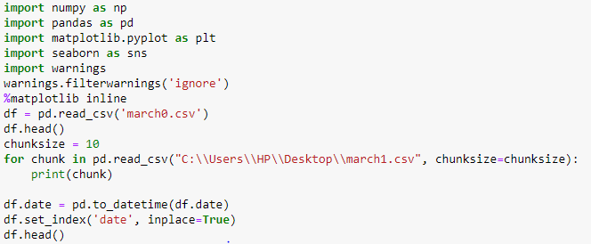

**OUTPUT:**

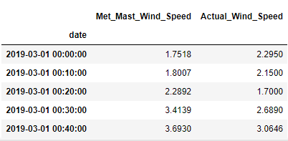

**2.4.2. ARIMA MODEL**

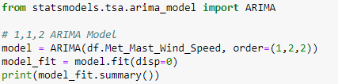

**OUTPUT:**

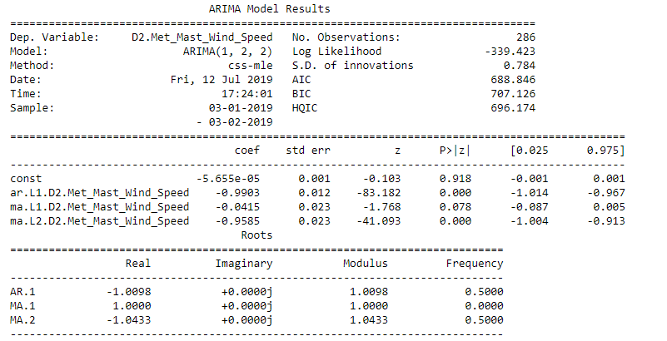

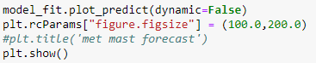

**OUTPUT:**

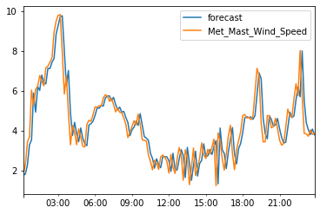**2.4.2. Prediction plot**

**2.4.3.TRAINING AND TEST:**

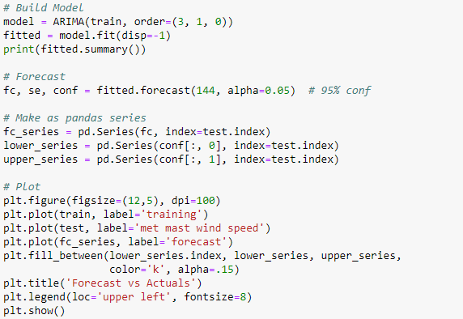

**OUTPUT:**

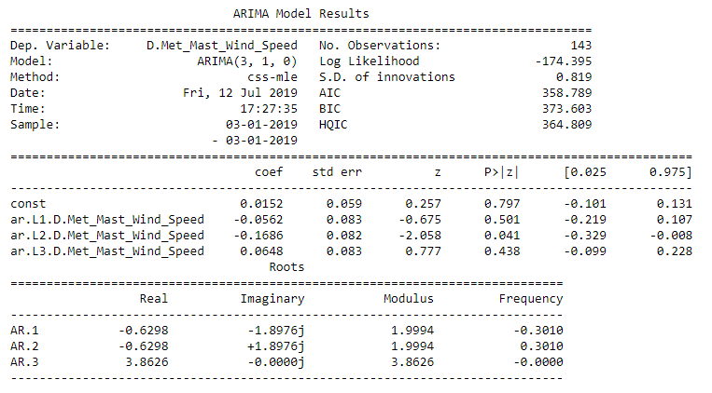

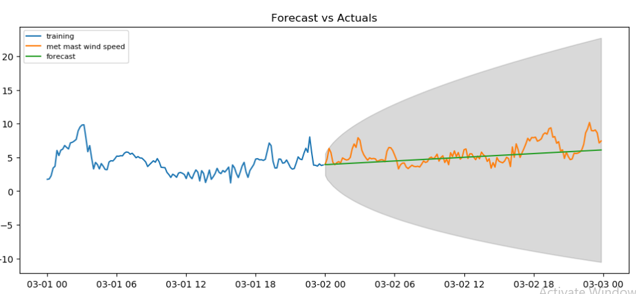

**2.4.3. Wind speed forecasting plot**

**2.4.4. ACCURACY:**

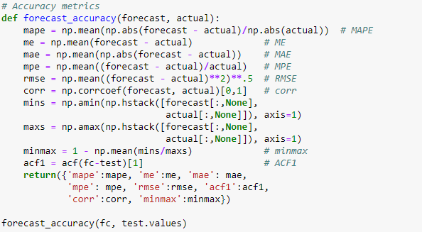

**OUTPUT:**

{'mape': 0.23283007071038483,

'me': -0.03163500589819844,

'mae': 0.8303964220590987,

'mpe': 0.08122255823546266,

'rmse': 1.0833519549346429,

'acf1': 0.6094760373679385,

'corr': 0.5788654228175466,

'minmax': 0.18041326036563932}

**2.4.5.POWER FORECAST:**

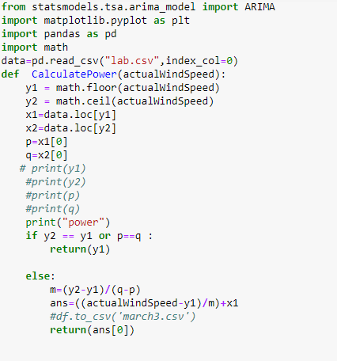

**OUTPUT:**

Forecast wind speed:

2.645828552165926

power

23.249827877973342

Forecast wind speed:

2.880984306245734

power

31.71543502484642

Forecast wind speed:

3.260177148515883

power

70.60356075261242

Forecast wind speed:

3.1025673689089346

power

49.6414600648883

.

.

.

.

Forecast wind speed:

4.569984720313584

power

295.53660790961555

Forecast wind speed:

4.594697225358909

power

301.02278402967784

Forecast wind speed:

4.619409728005876

power

306.5089596173045

**2.4.6. Deviation:**



**Output:**

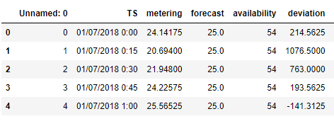

**Output:** 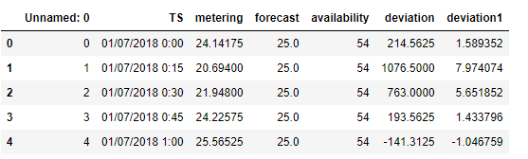



**Output:**

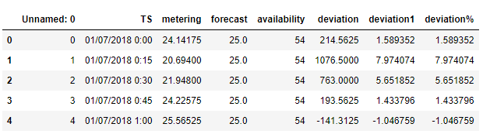

**2.4.7. PENALTY:**

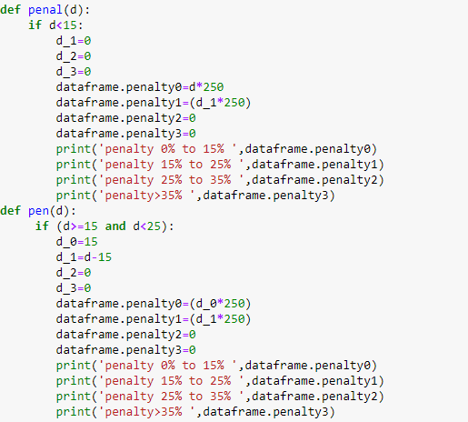

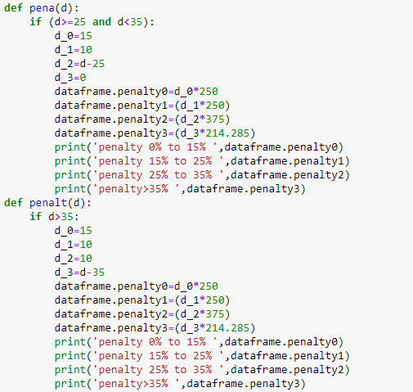

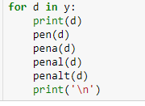

**OUTPUT:**

|  |  |  |  |  |  |  |  |  |
| --- | --- | --- | --- | --- | --- | --- | --- | --- |
| Actual | Available | Forecast | Deviation  (%) | Deviation | Penalty  15% | Penalty  15%-25% | Penalty  25%-35% | Penalty  >35% |
| 46 | 100 | 70 | 24% | 6000 | 3750 | 2250 | 2250 | 6750 |
| 37 | 100 | 70 | 33% | 8250 | 3750 | 2500 | 2000 | 3250 |
| 0 | 100 | 70 | 70% | 17500 | 3750 | 2500 | 3750 | 16250 |

* 1. **ABOUT COMPANY:**



**KAIGA GENERATING STATION** is a nuclear power generating station situated at [Kaiga](https://en.wikipedia.org/wiki/Kaiga), near the river [Kali](https://en.wikipedia.org/wiki/Kalinadi), in [Uttar Kannada](https://en.wikipedia.org/wiki/Uttar_Kannada) district of [Karnataka](https://en.wikipedia.org/wiki/Karnataka), India. The plant has been in operation since March 2000 and is operated by the [Nuclear Power Corporation of India](https://en.wikipedia.org/wiki/Nuclear_Power_Corporation_of_India).

It has four units. The fourth unit went critical on 27 November 2010.[[2]](https://en.wikipedia.org/wiki/Kaiga_Atomic_Power_Station#cite_note-2) The two oldest units comprise the west half of the site and the two newer units are adjoining the east side of the site. All of the four units are small-sized pressurized heavy water reactors of 220 [MW](https://en.wikipedia.org/wiki/Megawatt).

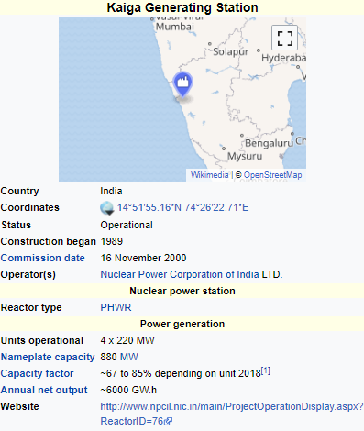

* 1. **HISTORY:**

On 27 November 2010 the Kaiga Atomic Power Station unit 4 of 220 MW capacity became operational.

On 19 January 2011, unit 4 with 220 MW capacity was connected to the southern power grid at 01:56 hours. With this, the total capacity rose to 880 MW making it the third largest in India after [Tarapur](https://en.wikipedia.org/wiki/Tarapur_Atomic_Power_Station) (1400 MW) and [Rawatbhata](https://en.wikipedia.org/wiki/Rajasthan_Atomic_Power_Station) (1180 MW). The unit, fueled by indigenous uranium, will supply electricity to [Karnataka](https://en.wikipedia.org/wiki/Karnataka), [Andhra Pradesh](https://en.wikipedia.org/wiki/Andhra_Pradesh), [Kerala](https://en.wikipedia.org/wiki/Kerala), [Tamil Nadu](https://en.wikipedia.org/wiki/Tamil_Nadu) and [Pondicherry](https://en.wikipedia.org/wiki/Puducherry).

In December 2018, it got the distinction of setting a world record of continuous operation among all nuclear power plants. As on December 10, 2018, KGS-1, which was synchronized to India's Southern grid on May 13, 2016, continues to operate for a record number of 962 days. Previous record of continuous operation was held by [Unit 8 of Heysham II](https://en.wikipedia.org/wiki/Heysham_nuclear_power_station), which operated from February 18, 2014 to September 15, 2016 for a record number of 940 days.

Two PHWR units each producing 700 MW have been planned for this location. As of February 2017 pre-project activities have begun for them and if everything goes as planned the first of the two will become critical around 2024-25.

1. **INTERNSHIP ACTIVITIES**

Introduction to Transducers and Instruments

* **Reasons for using Transducers:**
* They convert physical quantity to electrical quantity
* Mass and Inertia effects are minimized
* Less friction is produced
* The data can be stored and used for process control with the help of digital computers.
* Telemetry
* Easy to Measure
* Electrical and electronic systems can be controlled with very small power level.
* **Classification of transducers :**

1. **Based on the transducers working principle**

**-Resistive**

**-Capacitive**

**-Inductive**

1. **Based on the power required**

**-Passive**

**-Active**

1. **Type 3**

**-Primary**

**-Secondary**

1. **Type 4**

**-Analog**

**-Digital**

1. **Type 5**

**-Transduce**

**-Inverse Transducer**

**2.1 OPTICAL TRANSDUCERS**

**Experiments conducted:**

* + 1. **EXPERIMENT-1**

Aim: CHARACTERISTICS OF PHOTOVOLTAIC CELL.

Circuit Diagram:

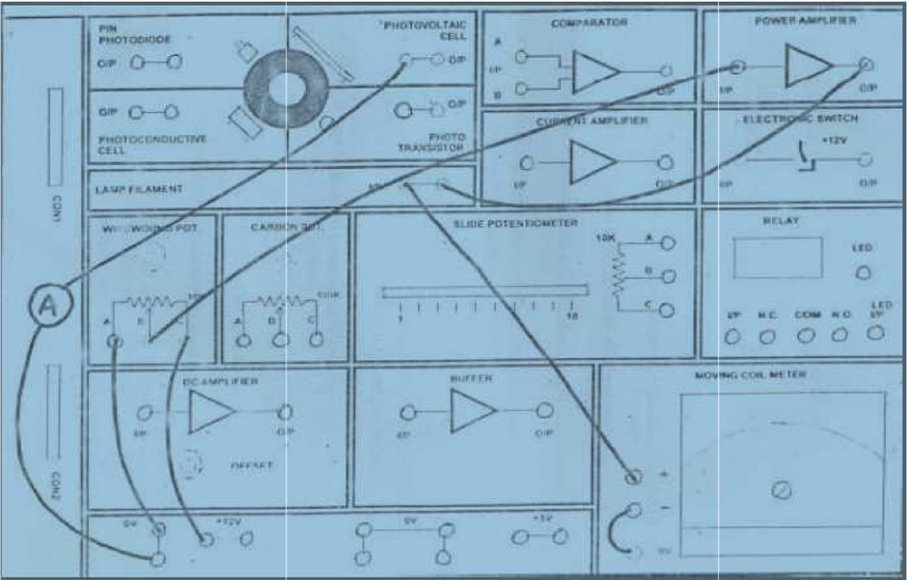

Procedure:

1. The circuit is completed as shown in the figure

2. All components are checked for working condition

3. Power supply is switched on

4. By rotating the knob of wire wound pot voltage can be varied, this illuminates the filament bulb and intensity is varied.

5. Note down the reading at 0V from voltmeter and current reading from Voltmeter.

6. Increase the voltage by the steps of 1V and note down the reading

Observation Table:

|  |  |  |  |  |  |  |  |  |  |  |  |
| --- | --- | --- | --- | --- | --- | --- | --- | --- | --- | --- | --- |
| **Lamp**  **Filament**  **Voltage**  **(volts)** | 0 | 1 | 2 | 3 | 4 | 5 | 6 | 7 | 8 | 9 | 10 |
| **Lamp Filament current**  (mA) | 0.13 | 21.44 | 32.69 | 42.05 | 49.89 | 57.12 | 63.80 | 69.94 | 75.62 | 81.42 | 86.33 |
| **lamp**  **Filament**  **Power**  (V x I)  (mW) | 0 | 21.44 | 65.38 | 126.15 | 199.56 | 285.6 | 382.8 | 489.58 | 604.96 | 732.78 | 863.3 |
| **Lamp**  **Filament**  **Resistance**  (V /I)  (ohms) | 0 | 0.0466 | 0.0612 | 0.0713 | 0.0802 | 0.0875 | 0.0940 | 0.1000 | 0.1058 | 0.1105 | 0.1158 |

Result:

Experiment is conducted and verified.

* + 1. **EXPERIMENT-2**

Aim**:** CHARACTERISTICS OF PIN PHOTODIODE.

Circuit Diagram:

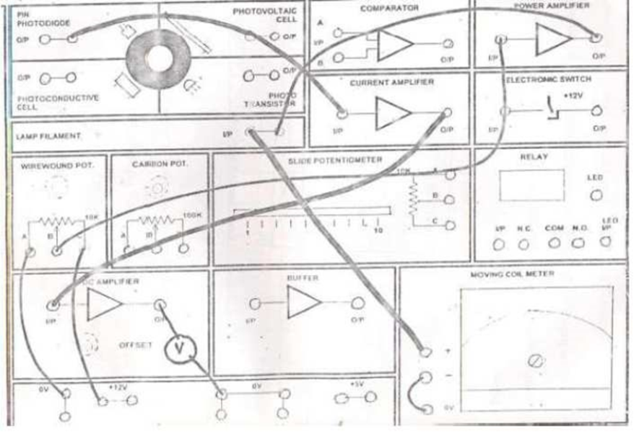

Procedure:

The circuit is completed as shown in the figure.

1. All the components are checked for working condition.
2. Power supply is switched on.
3. In the first case, keep the DC amplifier connected to the circuit.
4. By rotating the knob of wire wound pot. , the voltage can be varied. This illuminates the filament bulb and intensity is varied.
5. Note down the reading at 0V.
6. By increasing the voltage in steps of 1V, readings are noted.
7. Now disconnect the DC amp and connect to the BUFFER amp.
8. Note down the readings.

Observation table:

|  |  |  |  |  |  |  |  |  |  |  |  |
| --- | --- | --- | --- | --- | --- | --- | --- | --- | --- | --- | --- |
| Lamp Filament  Voltage(V) | 0 | 1 | 2 | 3 | 4 | 5 | 6 | 7 | 8 | 9 | 10 |
| PIN Photodiode DC Amplifier output voltage  \Volts() | 0.06  7 | 0.093 | 0.114 | 0.168 | 0.289 | 0.509 | 0.813 | 1.265 | 1.853 | 2.510 | 3.456 |
| PIN Photodiode  Buffer output  (v) | 0.41 | 0.063 | 0.140 | 0.373 | 0.853 | 1.773 | 2.481 | 2.787 | 3.006 | 3.119 |  |

Result*:*

Respective experiment is conducted and verified

* + 1. **EXPERIMENT-3**

Aim: CHARACTERISTICS OF PHOTOCONDUCTIVE CELL

Circuit Diagram:

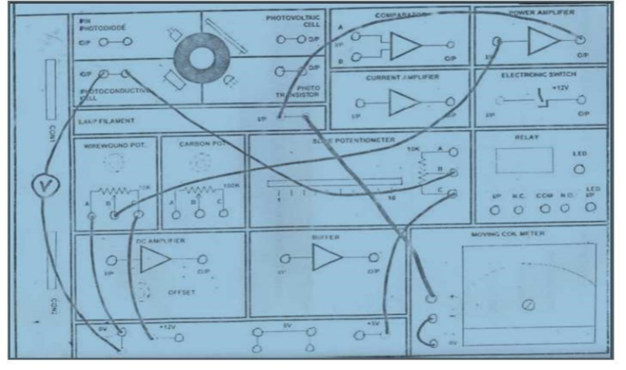

Procedure:

1. The circuit is completed as shown in the figure.
2. All the components are checked for working condition.
3. Power supply is switched on.
4. Keep the slide potentiometer in 3K position.
5. By rotating the knob of wire wound pot., voltage can be varied. This illuminates the filament bulb and intensity is varied.
6. Note down the reading at 0V from voltmeter and current reading from voltmeter.
7. Increase the voltage by the steps of 1V and note down the readings.

Observation Table:

|  |  |  |  |  |  |  |  |  |  |  |  |
| --- | --- | --- | --- | --- | --- | --- | --- | --- | --- | --- | --- |
| **LAMP FILAMENT**  **VOLTAGE(VOLTS)** | **0** | **1** | **2** | **3** | **4** | **5** | **6** | **7** | **8** | **9** | **10** |
| **Photo conductive cell**  **Adjust**  **voltage (Volts)** | **4.971** | **4.967** | **4.834** | **4.002** | **2.644** | **1.727** | **1.167** | **0.771** | **0.571** | **0.426** | **0.345** |

Result:

Respective experiment is conducted and verified.

**EXPERIMENT-4**

Aim: CHARACTERISTICS OF PHOTOTRANSISTOR CIRCUIT

Circuit Diagram:-

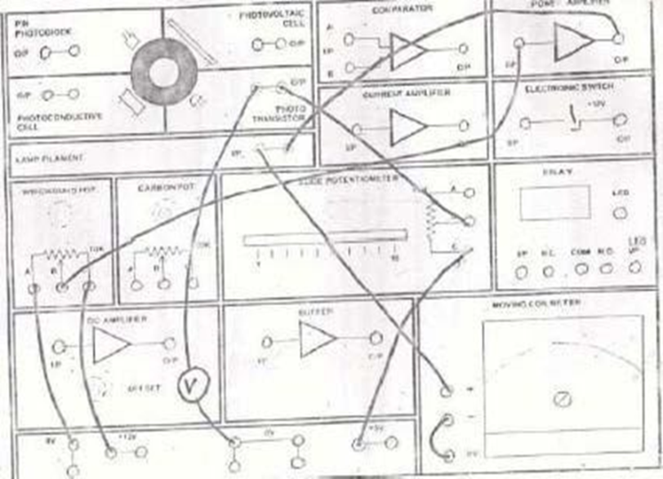

Procedure:

1. Circuit is connected is as shown in the figure.

2. Set the 10K ohm slide potentiometer control to min setting (1K ohm).

3. Switch on power supply and set the 10k ohm wire wound resistor to min for 0 output voltage from power amplifier.

4. Take readings of phototransistor output voltage as indicated on DMM as the lamp

Voltage is increased in 1 V step.

Observation Table:-

|  |  |
| --- | --- |
| **Lamp Filament**  **Voltage (V)** | **Photo Transistor**  **o/p Voltage(V)** |
| 0 | 4.940 |
| 1 | 4.938 |
| 2 | 4.936 |
| 3 | 4.934 |
| 4 | 4.889 |
| 5 | 4.619 |
| 6 | 3.734 |
| 7 | 1.784 |
| 8 | 0.811 |
| 9 | 0.780 |
| 10 | 0.762 |

Result:

Experiment is conducted and verified.

**Experiment- 5**

Aim: CHARACTERISTIC OF FILAMENT LAMP

Procedure:

1. Connect the circuit as required for the operation of filament lamp.
2. Switch on the supply.
3. Go on increasing the voltage scale by 1 step.
4. And take the corresponding readings of current.
5. Find the power.

Observation Table:-

|  |  |  |  |  |  |  |  |  |  |  |  |
| --- | --- | --- | --- | --- | --- | --- | --- | --- | --- | --- | --- |
| **Lamp filament voltage (V)** | **0** | **1** | **2** | **3** | **4** | **5** | **6** | **7** | **8** | **9** | **10** |
| **Lamp filament current(mA)** | 0.14 | 20.73 | 31.93 | 41.09 | 49.94 | 56.74 | 63.67 | 69.58 | 75.28 | 85.56 | 86.74 |
| **Lamp filament power (mW)** | 0 | 22.36 | 64.44 | 122.14 | 198.90 | 280.75 | 384.08 | 486.12 | 600.45 | 730.88 | 868.6 |
| **Lamp resistance (ohms)** | **0** | **0.045** | **0.058** | **0.069** | **0.080** | **.088** | **0.096** | **0.105** | **0.109** | **0.112** | **0.116** |

Result:-

Experiment is conducted and verified.

**2.2. COIS (Computerized Operator Information System)**

It is a data acquisition and Display system for providing the operator with

Process parameter values and status

* Alarm messages
* History
* Printouts
* ECCS Test
* DNM Test

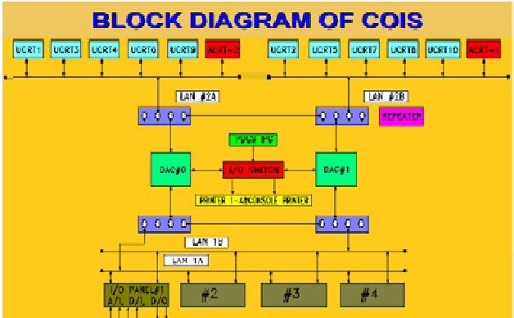

Fig, 2.2.1.Block diagram of COIS

FUNCTIONS OF DATA AQUISITION SYSTEM:

Appl. Software – written in “c” functions:

– acquire data from I/O system

– pass the required data to

Display stations

– Alarm task

– Printer task

– Storage of history

– Data base management

– Network management

– Carryout dnm and eccs testing

– govern the field output Contacts

**2.3. REPEATER**

An active component which can be used to connect different cables of networks .It isolates the remaining

Network from a fault in some other cable. For healthiness of repeaters check the flashing on all 4 repeaters every second.

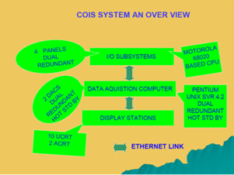

Fig. 2.2.2.COIS system overview

Function of display stations:

ALARM CRT (ACRT) - 2 NOS

– to alert the operator in case of alarm

UTILITY CRT(UCRT) - 10 NOS

– to display the various plant parameters in the desired formats as required by operator.

– to display the latest alarm/normal message at the bottom of all ucrts.

– to carry out the eccs and dnm testing.

– to get the desired printouts on any demand printer.

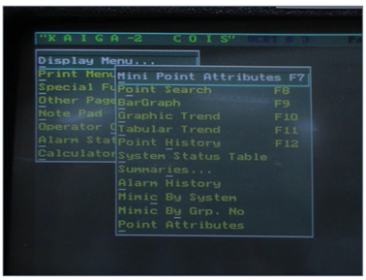

Fig. 2.2.3.COIS display

Standard color coding for analog and digital inputs:

Green –normal

Red-Alarm

Blue-Bad signal

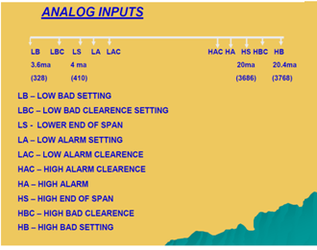

Fig.2.2.4.COIS analog inputs

PRINTERS:

Alarm printer no. - 3

Demand printers no. – 1, 2

Supplementary c/r printer- 4

It accepts command from SCR UCRT only i.e. UCRT 10

**2.3. PDCS (Programmable Digital Comparator System)**

PDCS is a real time computer based system

• Which scans, conditions and digitalizes field signals.

• Generates alarm contacts when parameter crosses the set limits.

• Provides a centralised facility for monitoring the input signals...

• Provide the analog output for COIS/DRS/IM

Features:

Controlled access for the operator

• Online test facility

• self diagnostic features

• Incorporation of redundancy fault tolerance and fail safeness in the design Parameters monitored with an accuracy of±0.25%ffull scale..

• Inputs are scanned once in every 100msec.

• Generation of alarm contacts within200msec,

• Current inputs are connected via 10 ohm resistor.

• Analog buffered outputs are 1 to 5v

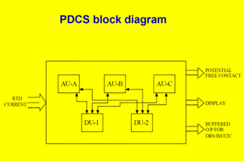

Fig.2.3.1. block diagram of PDCS

PDCS is functionally divided into an Alarm unit (AU) and Display unit (DU) with galvanic isolation.

Any problem in the DU side will not affect the functioning of AUs.

• AUs are triplicates (AU A,B,C )

•DUs are duplicated (DU 1,2 )

•With this type of design overall availability of the PDCS is 99.9 %

• AU, DU are based on 8687 CPU

Each AU receives 128 inputs.

A 1 to 255

B 1 to 255

C 1 to 255

Inputs are identified by odd numbers. It is possible to Disable/Enable/Set forced to alarm any NSR point for SR point sit is not possible

SR signals are routed through SR CDF located in channel rooms

NSR signals are routed through NSR CDF in Control room.

Valid Combinations:

SP1 should always be numerically lower than SP2 taking hysteresis into account.

|  |  |
| --- | --- |
| SP1 | SP2 |
| VL | L |
| L | VOID |
| VOID | L |
| HIGH | VOID |
| VOID | HIGH |
| HIGH | VERY HIGH |

ALARM RELAY ACTUATION

•When parameter moves over to alarm range. AU de energizes the alarm relay and contact will come open.

Alarm contact opens in case of power failure also.

• Both of the Alarm contact for particular PDCS point will open when signal goes to irrational low or irrational high condition.

**CONCLUSION OF THE REPORT**

After completing industrial training, I had been exposed to a programmer working life. Throughout my internship, I could understand more about the definition of an IT programmer and prepare myself to become a responsible and innovative technician and programmer in future. Along my training period, I realize that observation is a main element to find out the root cause of a problem. Not only for my project but daily activities too. During my project, I cooperate with my colleagues and operators to determine the problems. Moreover, the project indirectly helps me to learn independently, discipline myself, be considerate/patient, self-trust, and take initiative and the ability to solve problems. Besides, my communication skills is strengthen as well when communicating with others. During my training period, I have received criticism and advice from engineers and technician when mistakes were made. However, those advices are useful guidance for me to change myself and avoid myself making the same mistakes again. In sum, the activities that I had learned during industrial training really are useful for me in future to face challenges in a working environment. Throughout the industrial training, I found that several things are important:

* **Critical and Analytical Thinking**

To organize our tasks and assignment, we need to analyse our problems and assignment, and to formulate a good solution to the problem. We would have to set contingency plan for the solution, so that we are well prepared for the unforeseeable situations.

* **Time Management**

As overall technician and programmer are always racing against tight timeline and packed schedule, a proper time management will minimize facing overdue deadlines. An effective time management allows us to do our assignment efficiently and meet our schedules. Scheduling avoids time wastage and allows us to plan and gaining more as a result.

* **Goal Management**

Opposing to a Herculean goal seemed to be reachable at first sight, it is better to sub-divide the goals to a few achievable tasks, so that we will be gaining more confidence by accomplishing those tasks.

* **Colleague Interactions**

In working environment, teamwork is vital in contributing to a strong organization. Teamwork is also essential in reaching the goals of the organization as an entity. Thus, communicating and sharing is much needed in the working environment. Therefore, we should be respecting each other in work, and working together as a team, instead of working alone. This is because working together as a team is easier in reaching our targets, rather than operating individually.